INFO 7290 (DWBI): HW03b – Bulk Copy In

Smit Patil

1. SQL Syntax to create table for Health_Care_Provider_Credential

USE [bcp]

GO

/****** Object: Table [dbo].[Health_Care_Provider_Credential] Script Date: 02-Oct-20 7:24:18 PM ******/

SET ANSI_NULLS ON

GO

SET QUOTED_IDENTIFIER ON

GO

CREATE TABLE [dbo].[Health_Care_Provider_Credential](

[CredentialNumber] [varchar](255) NULL,

[LastName] [varchar](255) NULL,

[FirstName] [varchar](255) NULL,

[MiddleName] [varchar](255) NULL,

[CredentialType] [varchar](255) NULL,

[Status] [varchar](255) NULL,

[BirthYear] [varchar](255) NULL,

[CEDueDate] [varchar](255) NULL,

[FirstIssueDate] [varchar](255) NULL,

[LastIssueDate] [varchar](255) NULL,

[ExpirationDate] [varchar](255) NULL,

[ActionTaken] [varchar](255) NULL

) ON [PRIMARY]

GO

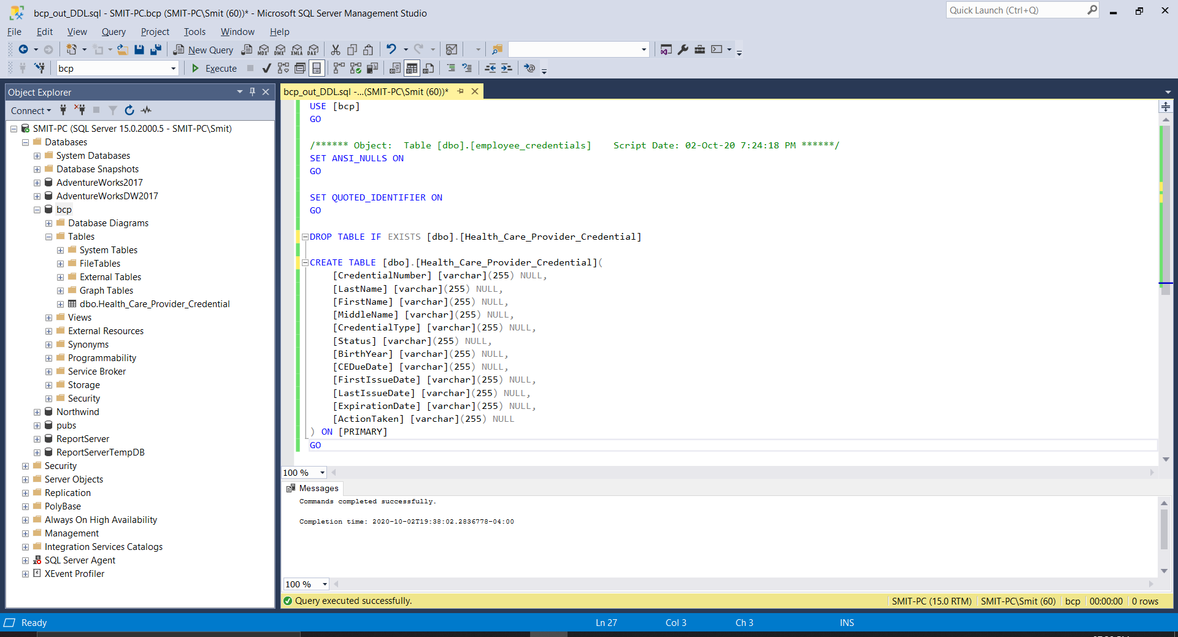

1. SQL Query to retrieve all the columns in the table Health_Care_Provider_Credential

SELECT [CredentialNumber]

,[LastName]

,[FirstName]

,[MiddleName]

,[CredentialType]

,[Status]

,[BirthYear]

,[CEDueDate]

,[FirstIssueDate]

,[LastIssueDate]

,[ExpirationDate]

,[ActionTaken]

FROM [bcp].[dbo].[Health_Care_Provider_Credential]

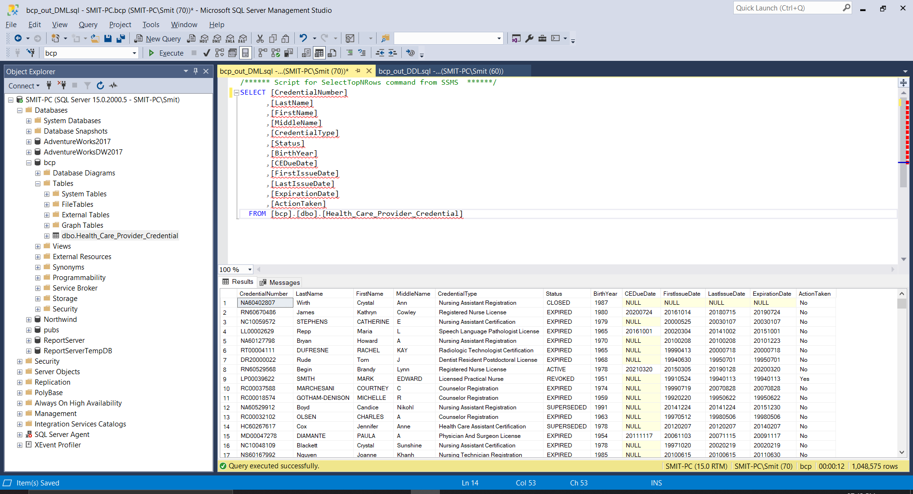

1. Commands to input data from Health_Care_Provider_Credential_data.csv file into SQL SERVER database(bcp) table(Health_Care_Provider_Credential).
   1. bcp Health_Care_Provider_Credential in Health_Care_Provider_Credential_Data.csv -S SMIT-PC -T -d bcp
   2. bcp Health_Care_Provider_Credential in Health_Care_Provider_Credential_Data.csv -S SMIT-PC -T -d bcp -f Health_Care_Provider_Credential_Data_In.fmt -F2
2. Execution and output screenshot of the command prompt(Next Page).

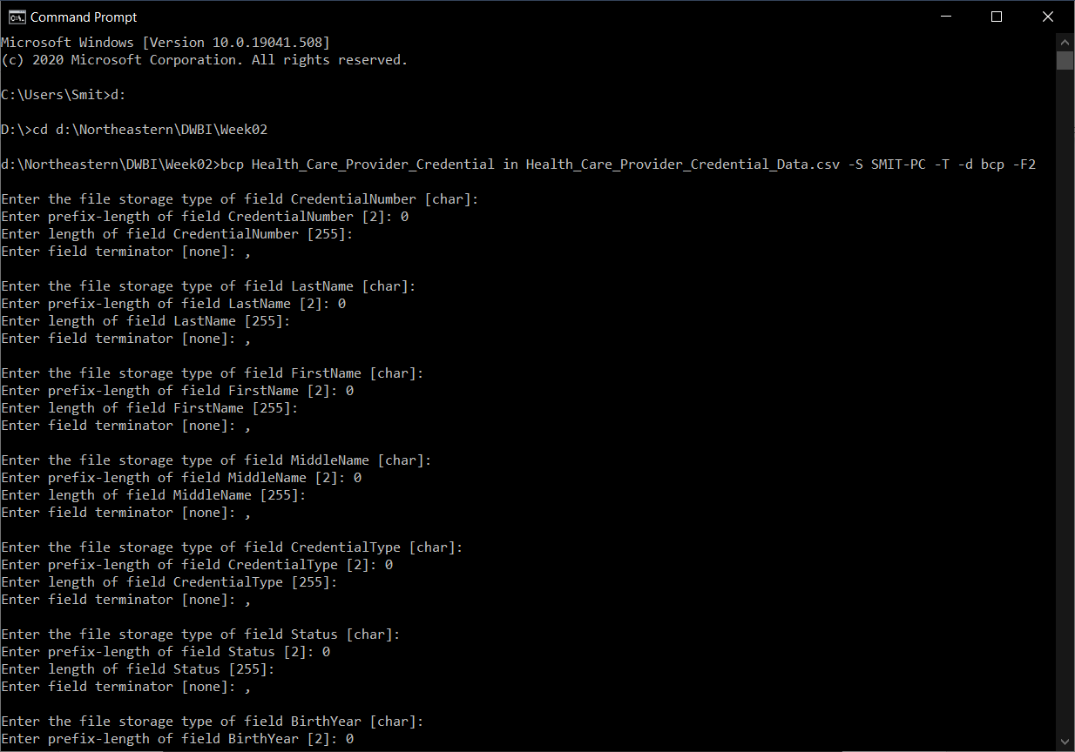 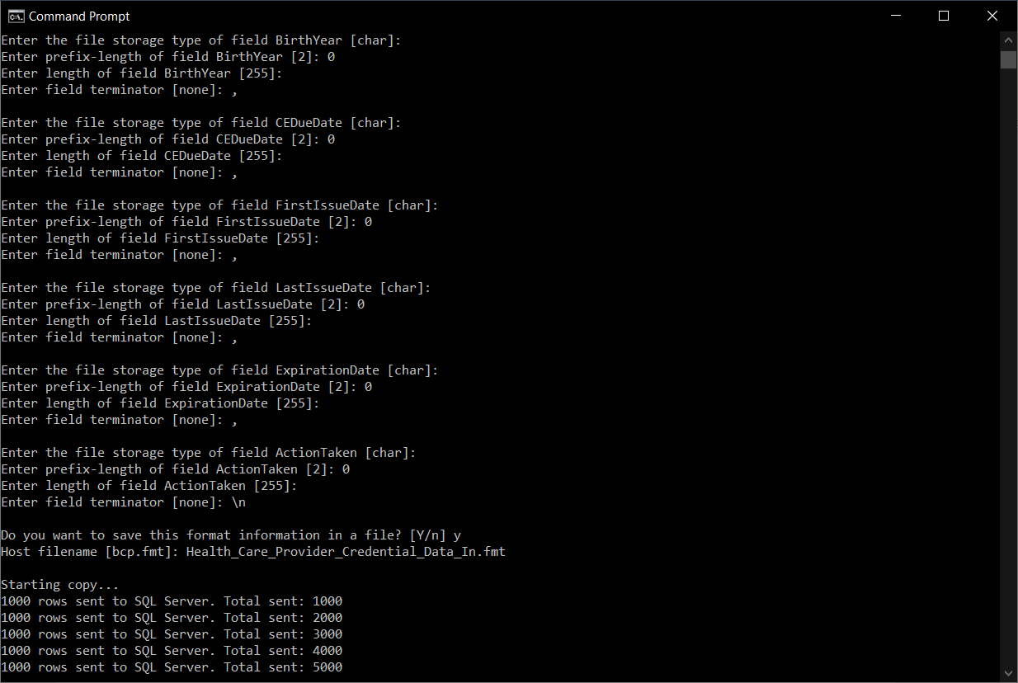 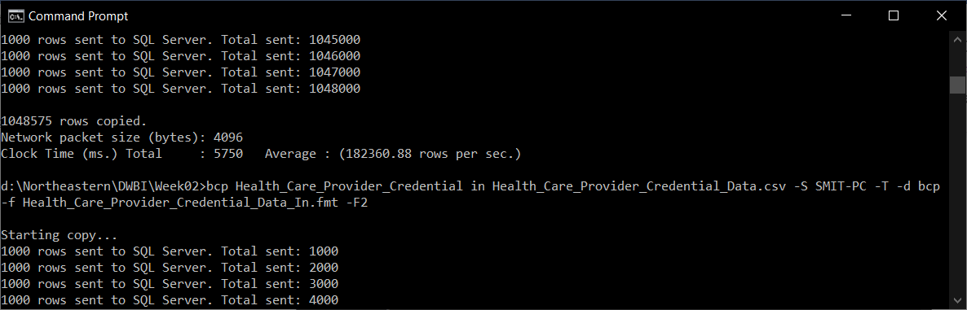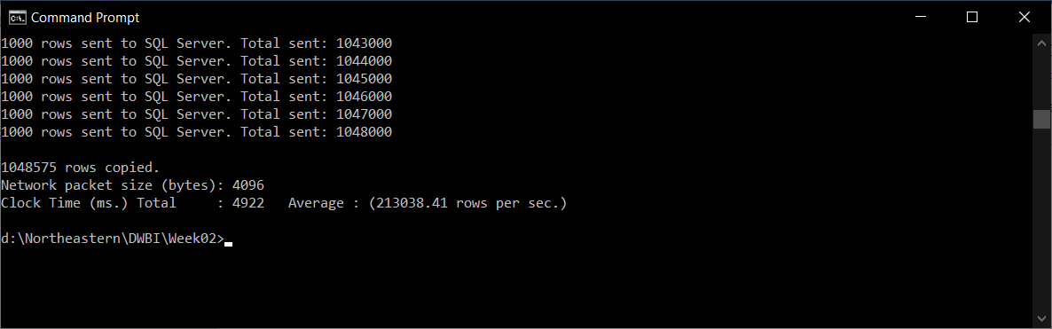

1. Format file output after executing the commands

